Sales Data Analysis and Business Insights

Name: Kanigashree.R
Date: March 2026

Executive Summary
This report presents a comprehensive analysis of sales data to identify trends, customer behaviour, and future sales opportunities. The analysis includes product performance, geographic sales distribution, customer segmentation using RFM analysis, and sales forecasting.
Key findings show that certain product categories and regions contribute significantly to revenue. Customer segmentation revealed valuable customer groups that can be targeted through personalized marketing strategies. Additionally, sales forecasting predicts future demand trends that can help businesses plan inventory and marketing campaigns.
The insights from this analysis provide actionable recommendations to improve business growth, customer retention, and operational efficiency.

1. Introduction
The purpose of this report is to analyze sales data and identify patterns that can help businesses make informed decisions. The analysis focuses on sales performance, customer behaviour, and forecasting future sales trends.
By understanding these factors, businesses can optimize inventory, improve marketing strategies, and enhance customer satisfaction.

2. Sales Performance Analysis
Monthly and Yearly Sales Trends
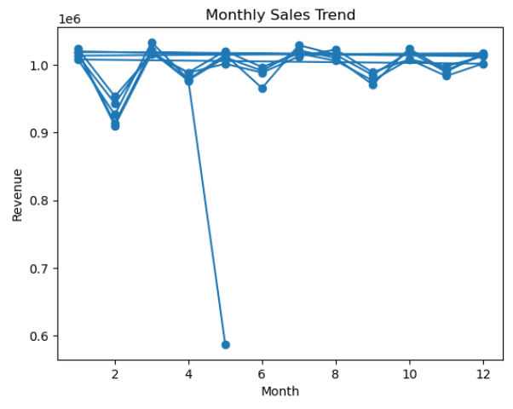

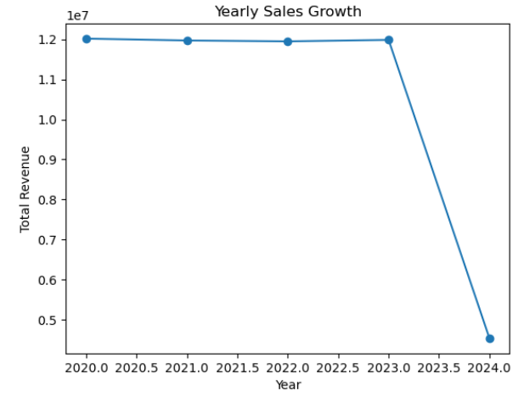
Key insights:
• Sales trends show fluctuations over time.
• Certain months demonstrate higher sales activity.
• Seasonal demand influences product performance.
Best-Selling Products and Categories
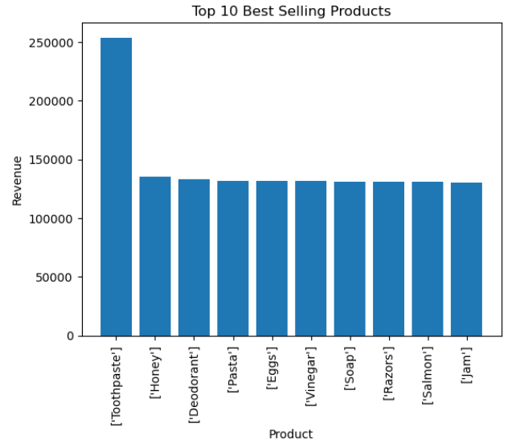

Findings:
• Top-performing products contribute a large portion of total revenue.
• Some categories consistently outperform others.
• Popular products show strong customer demand.
Geographic Sales Performance
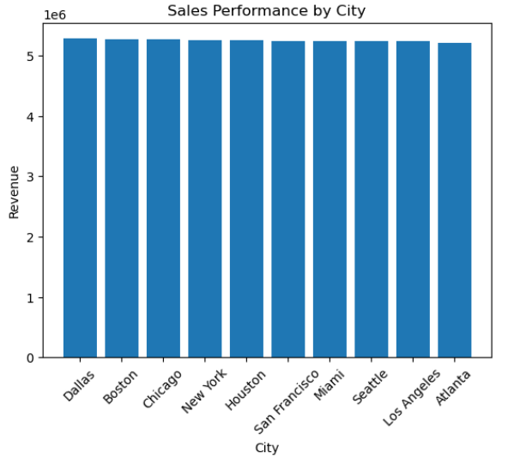
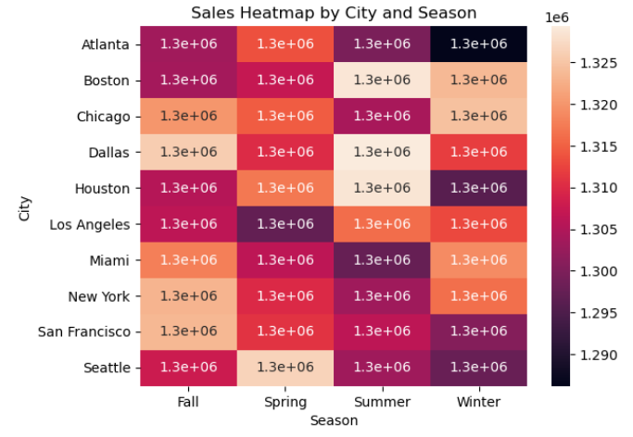
Insights:
• Certain regions generate higher sales compared to others.
• Urban areas show stronger purchasing activity.
• Some regions present opportunities for market expansion.

Customer Behaviour Analysis (RFM Analysis)
Customers were segmented based on:
- Recency
- Frequency
- Monetary value
Customer segments identified:
• High-Value Customers
• Loyal Customers
• Potential Loyalists
• At-Risk Customers
• Lost Customers
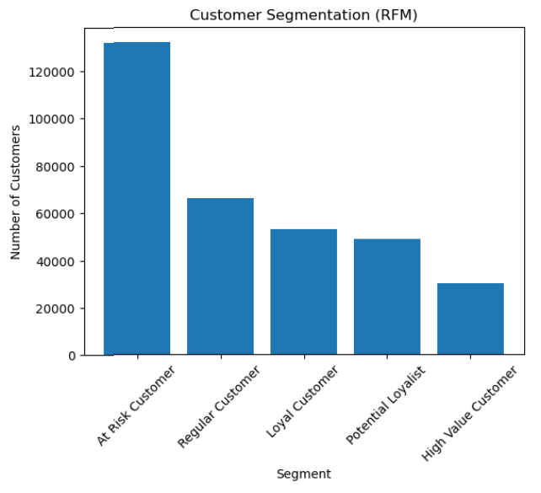
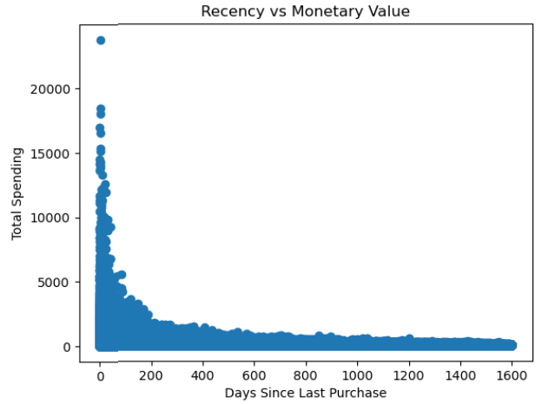
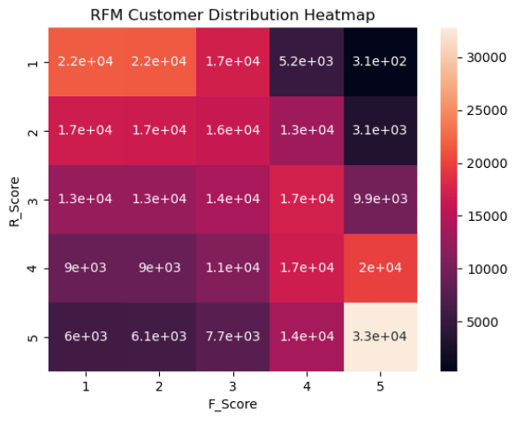
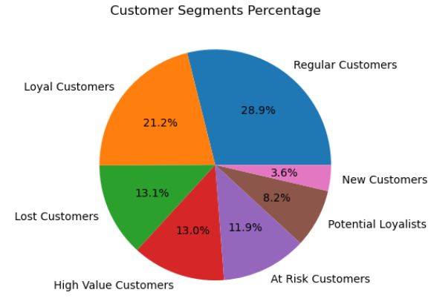
Key insights:
• High-value customers contribute significantly to revenue.
• Some customers require re-engagement strategies.
• Loyal customers show consistent purchasing behaviour.

Forecasting Insights
A time series forecasting model (ARIMA) was used to predict future sales based on historical data.
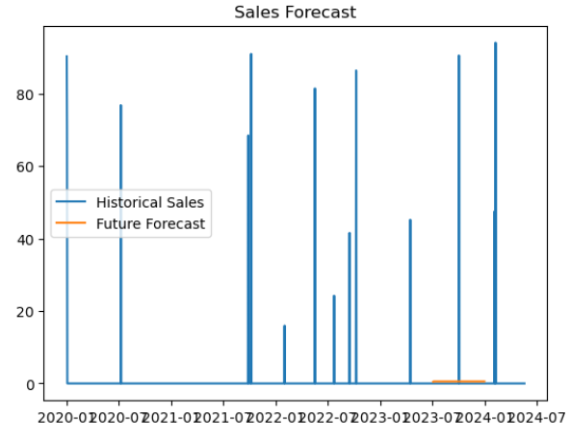
Key findings:
• Sales are expected to follow a similar trend in upcoming months.
• Certain periods may experience increased demand.
• Forecasting helps businesses prepare inventory and logistics.
Model Evaluation:
- RMSE: 7.73
- MAPE: 99.2

Business Opportunities
Based on the analysis, the following opportunities were identified:
- Expansion of high-demand product categories.
- Targeted marketing in high-performing regions.
- Upselling strategies for high-value customers.
- Customer retention programs for at-risk customers.
- Inventory planning using sales forecasts.
These opportunities can improve revenue growth and customer engagement.

Recommendations & Action Plan
Inventory Optimization
Increase stock levels for high-demand products to avoid shortages.
Targeted Marketing
Use personalized promotions for different customer segments.
Pricing Strategies
Adjust pricing based on seasonal demand and customer behaviour.
Customer Retention
Introduce loyalty programs and discounts for repeat customers.
Demand Forecasting
Use forecasting insights to improve supply chain management.

Conclusion
This analysis provided valuable insights into sales performance, customer behaviour, and future demand patterns. By leveraging these insights, businesses can make data-driven decisions to improve growth, customer retention, and operational efficiency.
Implementing the recommended strategies can help businesses optimize performance and stay competitive in the market.

